DESIGN PATTERNS
PYTHON IMPLEMENTATION
1. Singleton – Banking Management System
2. Factory Method – Travel Booking System

Assignment | Implementation details
Language | Python 3.8+
Pattern 1 | Singleton – centralized BankManager instance
Pattern 2 | Factory Method – Flight, Train and Bus booking objects
Deliverables | Source code, explanation, sample output and unit tests

1. Singleton Pattern – Banking Management System
Objective: Develop a banking system with a centralized BankManager responsible for common banking operations and system configuration. The Singleton pattern ensures that only one BankManager object exists and that all parts of the application share the same account data and configuration.

1.1 Class design
Class / member | Purpose
BankManager | Singleton class that centrally manages accounts and configuration.
__new__() | Creates the object only when the first instance is requested; later calls return the stored instance.
__init__() | Initializes the shared state once, using an initialization guard.
create_account() | Creates an account after validating the account number and opening balance.
deposit() / withdraw() | Performs basic balance operations with amount and funds validation.
get_balance() | Returns the current balance for an account.
update_configuration() | Updates a known system configuration setting.

1.2 Core Singleton implementation
class BankManager:
_instance = None
def __new__(cls, bank_name='City Bank'):
if cls._instance is None:
cls._instance = super().__new__(cls)
cls._instance._initialized = False
return cls._instance
def __init__(self, bank_name='City Bank'):
if self._initialized:
return
self.bank_name = bank_name
self.accounts = {}
self.configuration = {'currency': 'INR',
'minimum_balance': 1000, 'daily_withdrawal_limit': 50000}
self._initialized = True

1.3 Demonstrating a single instance
The two variables below refer to the exact same object. The identity operator `is` returns True. Changes made through one reference are visible through the other.
bank1 = BankManager('City Bank')
bank2 = BankManager('Another Bank')
print(bank1 is bank2) # True
print(bank2.bank_name) # City Bank

1.4 Banking operations
The complete source code implements account creation, deposit, withdrawal, balance inquiry and configuration updates. It rejects duplicate account numbers, negative or zero transaction amounts, withdrawals above the configured limit, and withdrawals that exceed the available balance.

2. Factory Method Pattern – Travel Booking System
Objective: Support Flight, Train and Bus bookings. The Factory Method pattern delegates object creation to specialized creator classes, allowing the client to request a booking without directly constructing the concrete booking class.

2.1 Class design
Component | Role
Booking | Abstract Product interface declaring confirm().
FlightBooking | Concrete product for flight reservations.
TrainBooking | Concrete product for train reservations.
BusBooking | Concrete product for bus reservations.
BookingCreator | Abstract Creator that declares create_booking() and provides the book() workflow.
FlightBookingCreator | Creates FlightBooking.
TrainBookingCreator | Creates TrainBooking.
BusBookingCreator | Creates BusBooking.
get_booking_creator() | Maps the customer's selection to the appropriate creator.

2.2 Factory Method structure
BookingCreator (abstract)
|-- FlightBookingCreator --> FlightBooking
|-- TrainBookingCreator --> TrainBooking
|-- BusBookingCreator --> BusBooking

2.3 Core Factory Method implementation
class BookingCreator(ABC):
@abstractmethod
def create_booking(self, passenger, origin, destination, date):
pass
def book(self, passenger, origin, destination, date):
booking = self.create_booking(passenger, origin, destination, date)
return booking.confirm()

class FlightBookingCreator(BookingCreator):
def create_booking(self, passenger, origin, destination, date):
return FlightBooking(passenger, origin, destination, date)
TrainBookingCreator and BusBookingCreator follow the same structure, returning TrainBooking and BusBooking respectively. The selection function validates the requested travel type and rejects unsupported choices.

3. Program execution and sample output
Run the program from the project folder with `python main.py`. The demonstration creates two BankManager references, proves that they are identical, performs transactions, and creates all three travel booking types.
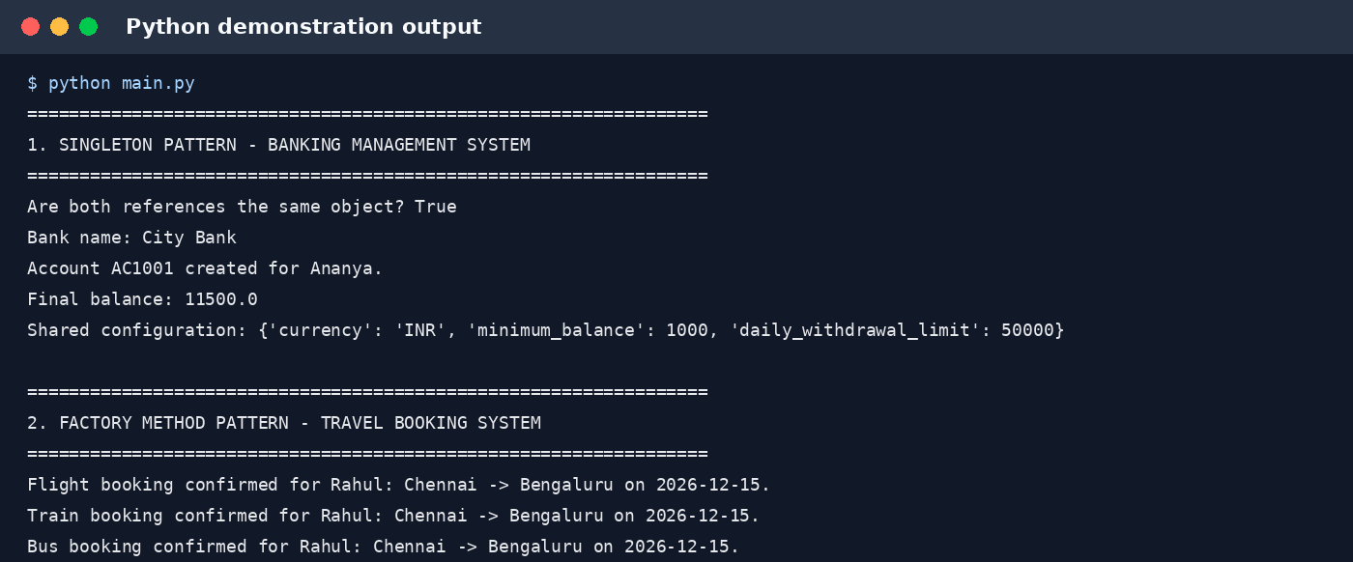

4. Testing and verification
Unit tests are included for Singleton identity, shared account state, insufficient-funds validation, creation of all three booking types, and invalid travel selection.
Test command:
python -m unittest discover -s tests -v
Verification result: the demonstration script executed successfully and all included unit tests passed.

5. How to run
- Install Python 3.8 or later.
- Extract the ZIP file to a folder.
- Open a terminal in the extracted project folder.
- Run: python main.py
- Run tests: python -m unittest discover -s tests -v

6. Conclusion
The Singleton pattern provides one shared BankManager instance for centralized banking operations and configuration. The Factory Method pattern separates the travel booking interface from concrete booking creation, making it straightforward to support Flight, Train and Bus bookings and to add further travel types with new creator/product classes.
Note: This is an educational in-memory implementation. It is not production banking or ticketing software. A production system would need secure authentication, persistent storage, concurrency controls, audit trails, live availability and payment-provider integration.

